Specialist Mathematics Units 3 & 4
Investigation 2 2018
Numerical Integration – In Class Validation

NAME: ____________________________________

TOTAL MARKS: 54 MARKS TIME: 55 MINUTES

CALCULATORS & TAKE HOME PAPER ALLOWED

A QUESTION OF ACCURACY

This investigation involves a variety of numerical methods used to evaluate integrals. Throughout you are required to give final results correct to 3 decimal places. To achieve this degree of accuracy, you will need to carry extra decimal places in earlier calculations.
When justifying your solutions you may use the sigma symbol with the correct formula, where appropriate, rather showing the full list of values.
______________________________________________________________________________

Question 1 [4,4,5,5,8 = 26 marks]

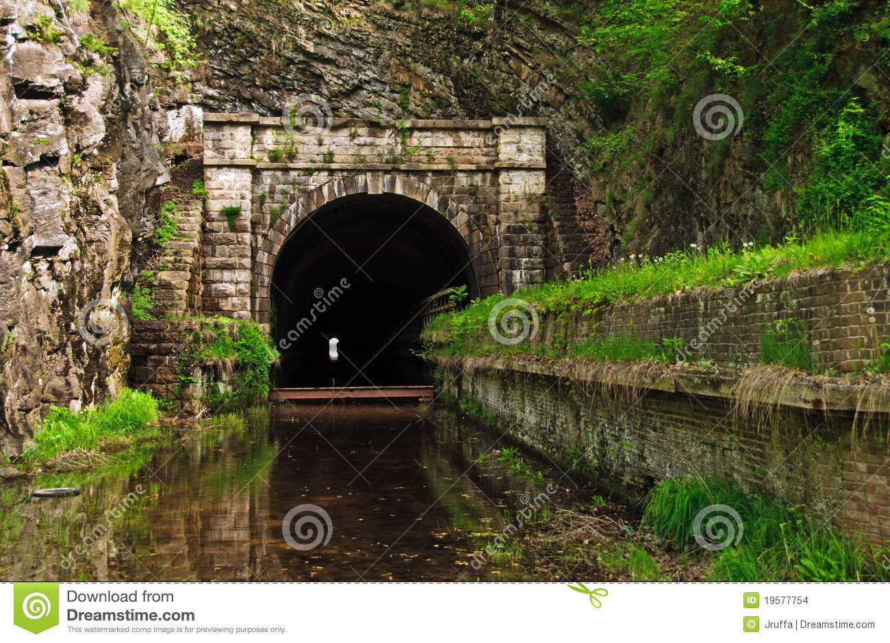
For the function $f(x)=\frac{x^{2}(9-x)}{20}$

a) Use the Trapezium Rule to find the total cross sectional area between $x=2$ and $x=8$

i) using 4 strips of equal width

ii) and 12 strips of equal width

b) Use Simpson’s rule to evaluate the same cross sectional area

i) using 4 strips of equal width

ii) and 12 strips of equal width

c) Assume that the function $f(x)=\frac{x^{2}(9-x)}{20}$ is the shape of the tunnel with each unit representing
one metre.
Using the largest percentage error featured above, how much more earth would be estimated to be removed than necessary if the tunnel is 400m long ?

MID POINT RULE
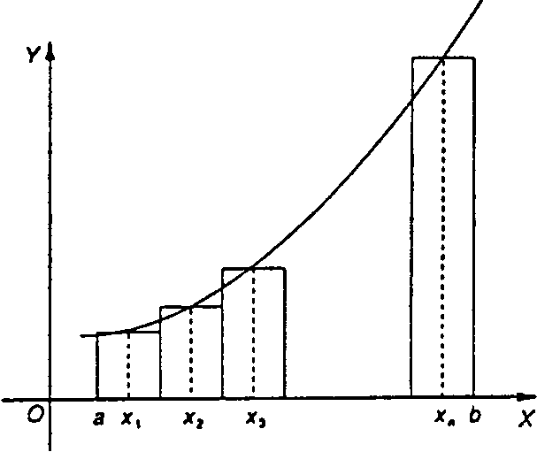
Let f be a continuous function in the interval [a; b]. Divide this interval into n subdivisions, each of width
Using these subdivisions as bases, n rectangles are drawn of width w and height f(x₁), f(x₂), f(x₃) where x₁,x₂, x₃are the x-coordinates of the mid-point of the subdivision, as illustrated in the figure below.

A numerical method of approximating the area of the region bounded by the curve the x-axis and the ordinates x=a and x= b is to calculate the sum of the areas of these rectangles:

Example
Use the mid-point rule to find, approximately, the area bounded by the parabola defined by , the x-axis and the lines x = 1 and x = 3, using four intervals.

The x-coordinates of the mid-points of each of the four intervals are x = 1.25, 1.75, 2.25 and 2.75 and .
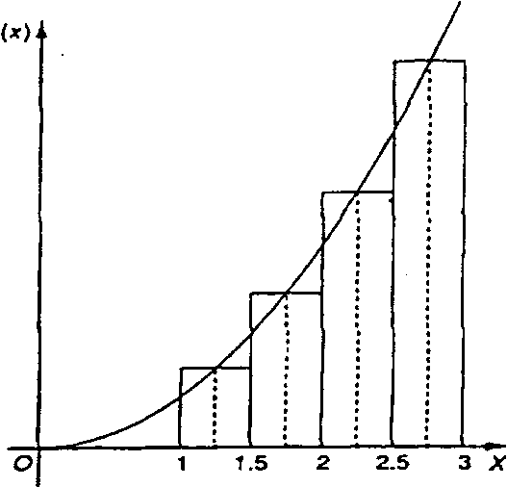
=
[f(l.25) + f (1.75) + f (2.25) + f (2.75)]

[l.5625 + 3.0625 +5.0625 + 7.5625]

$$x$$ | $$f(x)$$
0 | 2
0.1 | 2.210341836
0.125 | 2.266296906
0.2 | 20442805516
0.25 | 2.568050833
0.3 | 2.699717615
0.375 | 2.909982829
0.4 | 2.983649395
0.5 | 3.297442541
0.6 | 3.644237601
0.625 | 3.736491915
0.7 | 4.027505415
0.75 | 4.234000033
0.8 | 4.451081857
0.875 | 4.797750588
0.9 | 4.919206222
1.0 | 5.436563657
Question 2 [ 4,4,5,8,7 = 28 marks]
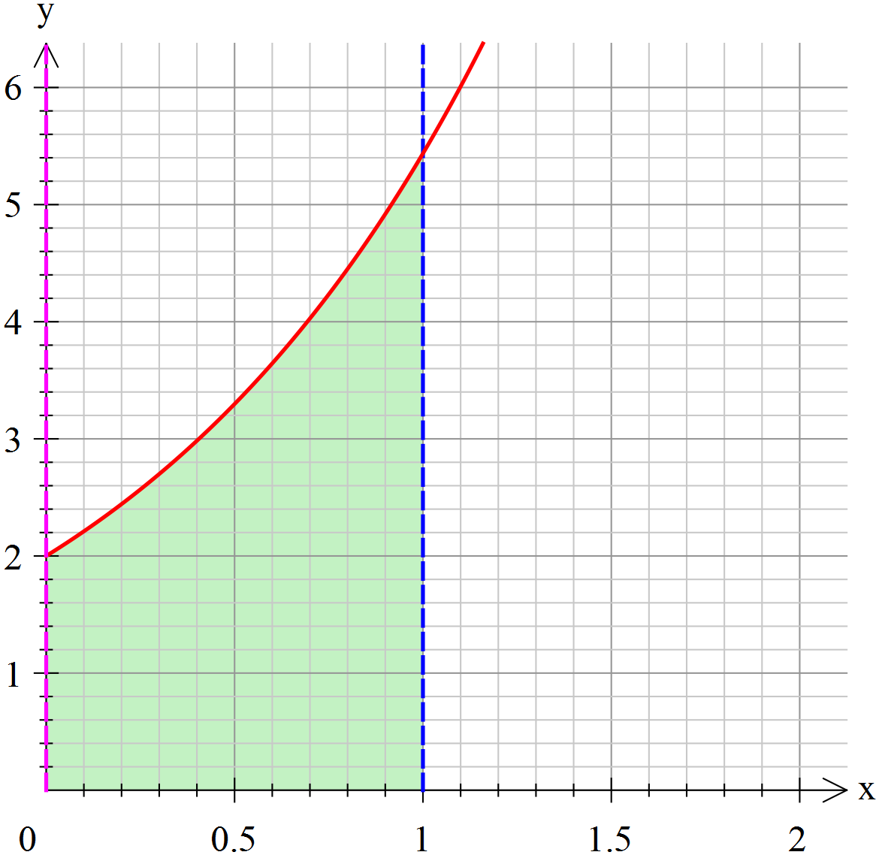
The graph and table shown show the graph of $y=f(x)$.
A table of values accompanies the graph.
Use 4 strips with each of the following methods to estimate the area under the graph corresponding to $\int_{0}^{1}{f\left(x\right)dx}$.
a) Mid-point method

b) Trapezium Rule

c) Simpson’s Rule

d) Use percentage errors to compare the relative accuracies of each method if the area under the graph is 3.436563657 units².

d) What advantage or characteristic does each rule have? Include any relevant general observations you may like to add.

